POLK COUNTY YOUTH FAIR
BREEDING ANIMAL RECORD BOOK

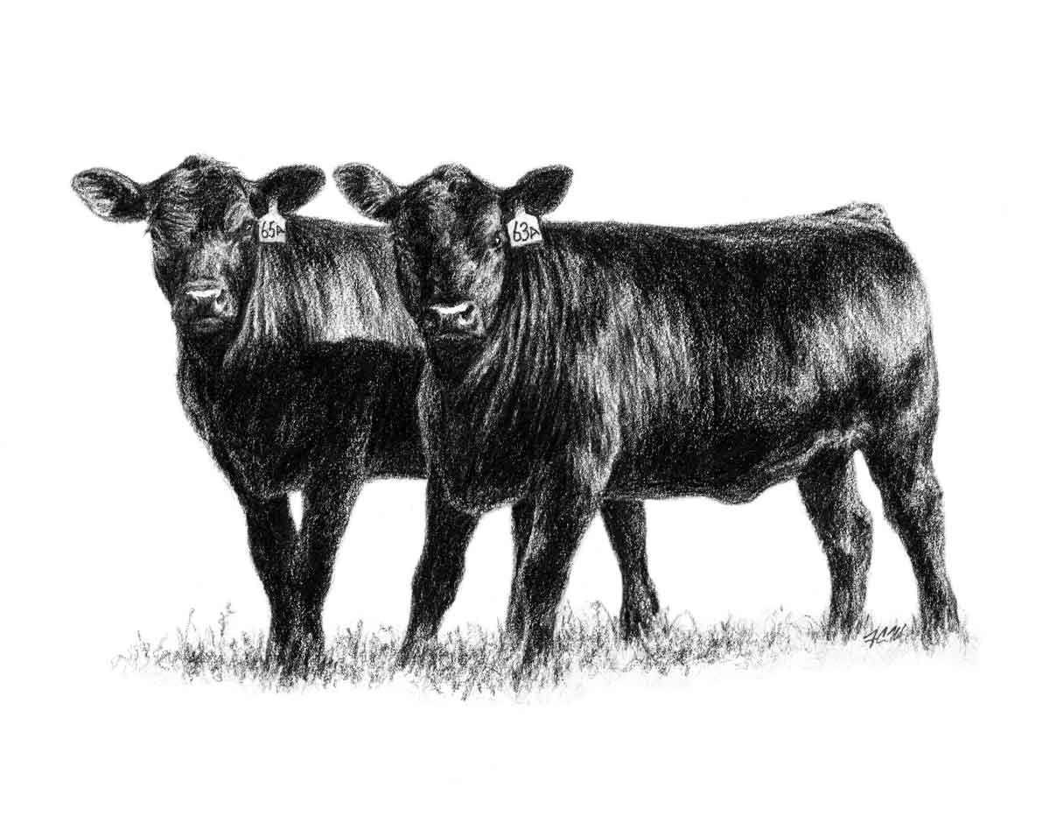

POLK COUNTY YOUTH FAIR
Breeding Animal Record Book

This record book is to be turned in at the time check in of your purebred breeding animals for judging.
Circle one: PUREBRED BEEF COMMERCIAL BEEF DAIRY GOAT RABBIT
EXHIBITOR NAME: AGE:
CLUB or CHAPTER:
I hereby certify that as the exhibitor of this project, I have personally been responsible for the care of this (these) animal (s), have personally kept records on this project, and have personally completed this record book.

Exhibitor’s signature _________________________________________ Date: _________________
I/ We the parents/Guardians certify that our son/daughter has completed this project and completed this record book and will comply with all the rules and regulations of this show.

Parent/Guardians Signature _______________________________________ Date: ______________
This child is a member of the _____________________________________FFA Chapter/ 4-H Club,
And is eligible to show livestock at the Polk County Youth Fair. I verify that this record book has been completed by the student and is an accurate representation of the project.

FFA advisor/ 4-H leaders signature ______________________________________ Date___________

1
Purpose:
THE PURPOSE OF A BREEDING ANIMAL YOUTH PROJECT IS TO ACHIEVE THE FOLLOWING:
- To acquire an understanding of animal production for caring for and keeping record for your animal(s)
- To acquire knowledge of feeding, caring, raising, breeding and marketing your fair animal(s).
- To understand the business aspects and responsibilities of your animal(s).
- To develop responsibility of your animal(s), record keeping, leadership, and knowledge of the
community.
*It is very important you take care of your animal, keeping them healthy, keeping them free from harmful drugs or harmful situations. You are responsible for your animals’ livelihood.
*This record book will be read, checked for dates, signature’s and calculations please make sure every page has been completed to the best of your ability.
* You may make copies of the animal pedigree page and feed log page if needed.
* You must have these items at check in:
__ Health Certificate __Registration Papers __Completed Record books
*You will be directed to your tie area after all paperwork has been approved.

DRUG STATEMENT
I HEREBY CERTIFY THAT ANY DRUG, ANTIBOTIC OR BIOLOGICAL SUBTANCE WHICH MAY HAVE BEEN ADMINSTERED BY MYSELF, OR ANY OTHER PERSON, WAS DONE SO IN STRICT COMPLIANCE WITH THE MANUFACTURES’ LABEL REQUIREMENTS OR UNDER A VETERINARIANS SUPERVISION.

_____________________________________________________________________________________ SIGNATURE OF STUDENT
_____________________________________________________________________________________SIGNATURE OF PARNET/ GUARDIAN

2
PROJECT ANIMAL INVENTORY:
All animals you own at the beginning of the project year and add any animal(s) you purchase, lease, or born to your animal during this project year. Animals SOLD must be recorded under your income page.
NAME | REG. NUMBER | BREED | SEX | BEGINNING VALUE $$ | DATE ACQUIRED
1
2
3
4
5
6
VALUE ANIMAL ASSETS | ************* | ********** | **** | $ | **********

ANIMAL MISC. NOTES:
ANIMAL # | ANY HEALTH OR BREEDING NOTES:
1

2
3
4
5
6

3

PEDIGREE AND BREEDING RECORDS: (make copies for Additional Animals)
IDENTIFICATION:

NAME: ________________________________________________________ REG. #_______________

DATE OF BIRTH: _______________________________________ EAR TAG # ____________________

ID BRAND __________________________________________________________________________

*IF NOT BRED AND OWNED:
DATE PURCHASED OR OBTAINED: ______________________________________________________

PURCHASED/ LEASED FROM: __________________________________________________________

PRICE: _____________________________________

PEDIGREE:
SIRE-___________________________________
NAME/NO.__________________________________
SIRE DAM-___________________________________

DAM SIRE-________________________________
NAME/NO.____________________________________
DAM-_________________________________

4
BREEDING RECORDS: (make copies for Additional Animals)

NATURAL BREEDING:
BREEDING RECORDS
DATE MALE IN DATE SIRE NO./ SIRE NAME BRED Y-YES OFFSPRING DUE DATE
EXPOSED REMOVED I.D. N-NO

ARTIFICIAL INSEMINATION:
BREEDING RECORDS
DATE DATE SIRE NO./ SIRE NAME BRED Y-YES OFFSPRING DUE
OBSERVED ESTRUS A.I. I.D. N-NO DATE

5

PRODUCTION RECORD: (make copies for Additional Animals)

DAM: NAME___________________________________________________________ REG #_______________________________________
DATE BORN OFFSPRING I.D. SIRE NAME SIRE I.D. SEX BIRTH WEIGHT WEAN WEIGHT
LB
LB
LB

DAM: NAME___________________________________________________________ REG #_______________________________________
DATE BORN OFFSPRING I.D. SIRE NAME SIRE I.D. SEX BIRTH WEIGHT WEAN WEIGHT
LB
LB
LB

SIRE BREEDING RECORDS:
SIRE: NAME___________________________________________________________ REG #_______________________________________
EXPOSER DATES: TURNED OUT IN HEARD; __________________________________ REMOVED FROM HEARD: ________________________
DATE BORN OFFSPRING I.D. DAM NAME DAM I.D. SEX BIRTH WEIGHT WEAN WEIGHT

6
HEALTH RECORDS:
List any wormers, fly control, and mineral
DATE | DESCRIPTION | PRODUCT | WITHDRAWAL | DOSEAGE

VET SERVICES:
DATE | DESCRIPTION OF WORK DONE | WITHDRAWAL IF ANY | NOTES

7

NON- FEED EXPENSES:
This should include entry fees, veterinary expenses, bedding, film, halters, show equipment, etc.…
DATE  AQUIRED | DESCRIPTION | Amount PAID | Depreciation (10% of purchased cost, per year | TOTAL AT VALUE END OF PROJECT
EXAMPLE  Prev. Year | Lead Rope | 5.00 | 1.00 | 4.00
CURRENT YEAR | PALPATE | 20.00 |  | 20.00
TOTAL DEPRECIATION EXPENSE
VALUE OF ASSETS
 | TOTAL NON-FEED EXPENSES:

8

FEED EXPENSES:
List all feed and hay expenses on this page (list hay and feed separately)
DATE | DESCRIPTION | PAID TO | POUNDS | COST
TOTAL FEED EXPENSE |  |  |  | $

9
INCOME PAGE:
Income from your project should be recorded here such as sales, show premiums or other money earned.
DATE | DESCRIPTION | TOTAL
 | TOTAL  *if none enter a zero | $

SPONSOR INCOME:
You should record any money given to you for support from a sponsor…You are responsible for collecting monies pledged.
SPONSORS NAME | Total
TOTAL SPONSOR INCOME  *if none enter a zero | $

$
TOTAL FROM THIS PAGE

10
PICTURES:
Show pictures of your project from beginning of your project year with captions, they should tell the story of what’s going on in your picture. A minimum of 4 pictures maximum of 8 pictures.

11
Project Questions:
What is your daily routine with your animal(s)?

What made you decide to show this breed?

After your animal(s) are finished showing at Polk County Youth fair what are your plans for the animal(s)?

12
SUMMARY:
INCOME:
Income (from page 11) $_________________
TOTAL INCOME #4

EXPENSE:
Non-feed expense (from page 8) $___________________
Feed expense (from page 10) $___________________
TOTAL EXPENSES #8

ANIMAL INVENTORY:
Animal inventory asset (from page) $________________
TOTAL ANIMAL ASSETS #11
Final Summary:
Profit/loss summary (BOX # 4- BOX #8) + BOX #11
13

EXHIBITOR NAME:
CLUB NAME:
CIRCLE ONE: JR. INT. SR.
JUDGES TALLY SHEET:
SECTION | POINTS | POINTS EARNED
- SIGNATURES | 3
2. Drug sheet | 5
3. project Inventory | 8
4. project Animal Inventory | 8
5. Non- Feed expenses | 8
6. Feed Expenses | 8
7. Income | 5
8. Breeding and Health records | 20
9. Project story | 20
10. Pictures | 5
11. Neatness | 10
TOTAL POINTS 100 points/
SCORE:

14

